# Experience

04/2011 to 05/2014

**Web Developer - Megan Rapinoe, CA, Remote from BD**

01/2015 to 05/2015

**Web Developer - droners.io, Utah, Remote from BD**

09/2015 to 05/2017

**Web Developer - Callen Cordero, Utah, Remote from BD**

07/2017 to 05/2019

**Web Developer - Play List Control, Australia, Remote from BD**

# Education

2009-2010

**Bachelor of Science: Harvard Extention Online, CSE**

2011-2012

**Bachelor of Science: FCC Online, CSE on JS**

# Certifications: I never take certificate simply becasue it doesn’t imply skill and software enginerring job doesn’t require certificate. Rather clients would see my work in GITHUB and my over the top problem solving skill.

# References

[www.rapinoe.us](http://www.rapinoe.us) [www.droners.io](http://www.droners.io) [www.playlistcontrol.com](http://www.playlistcontrol.com)

ABU SAYEED MONDAL

**Phone: +8801711412183**

[**sayeedmondal1412@gmail.com**](mailto:sayeedmondal1412@gmail.com)

**http://www.abusayeed.me**

**GIT:** https://github.com/psayeed1990

# Skill Highlights

* NodeJS
* JavaScript
* SQL
* Express
* GraphQL
* Apollo
* FaunaDB
* MongoDB
* Python
* Ruby
* PHP
* AWS
* Performance
* Security
* Design
* Database Design

# **Speaking** Languages

***English***

***Bengali***

***HIndi***

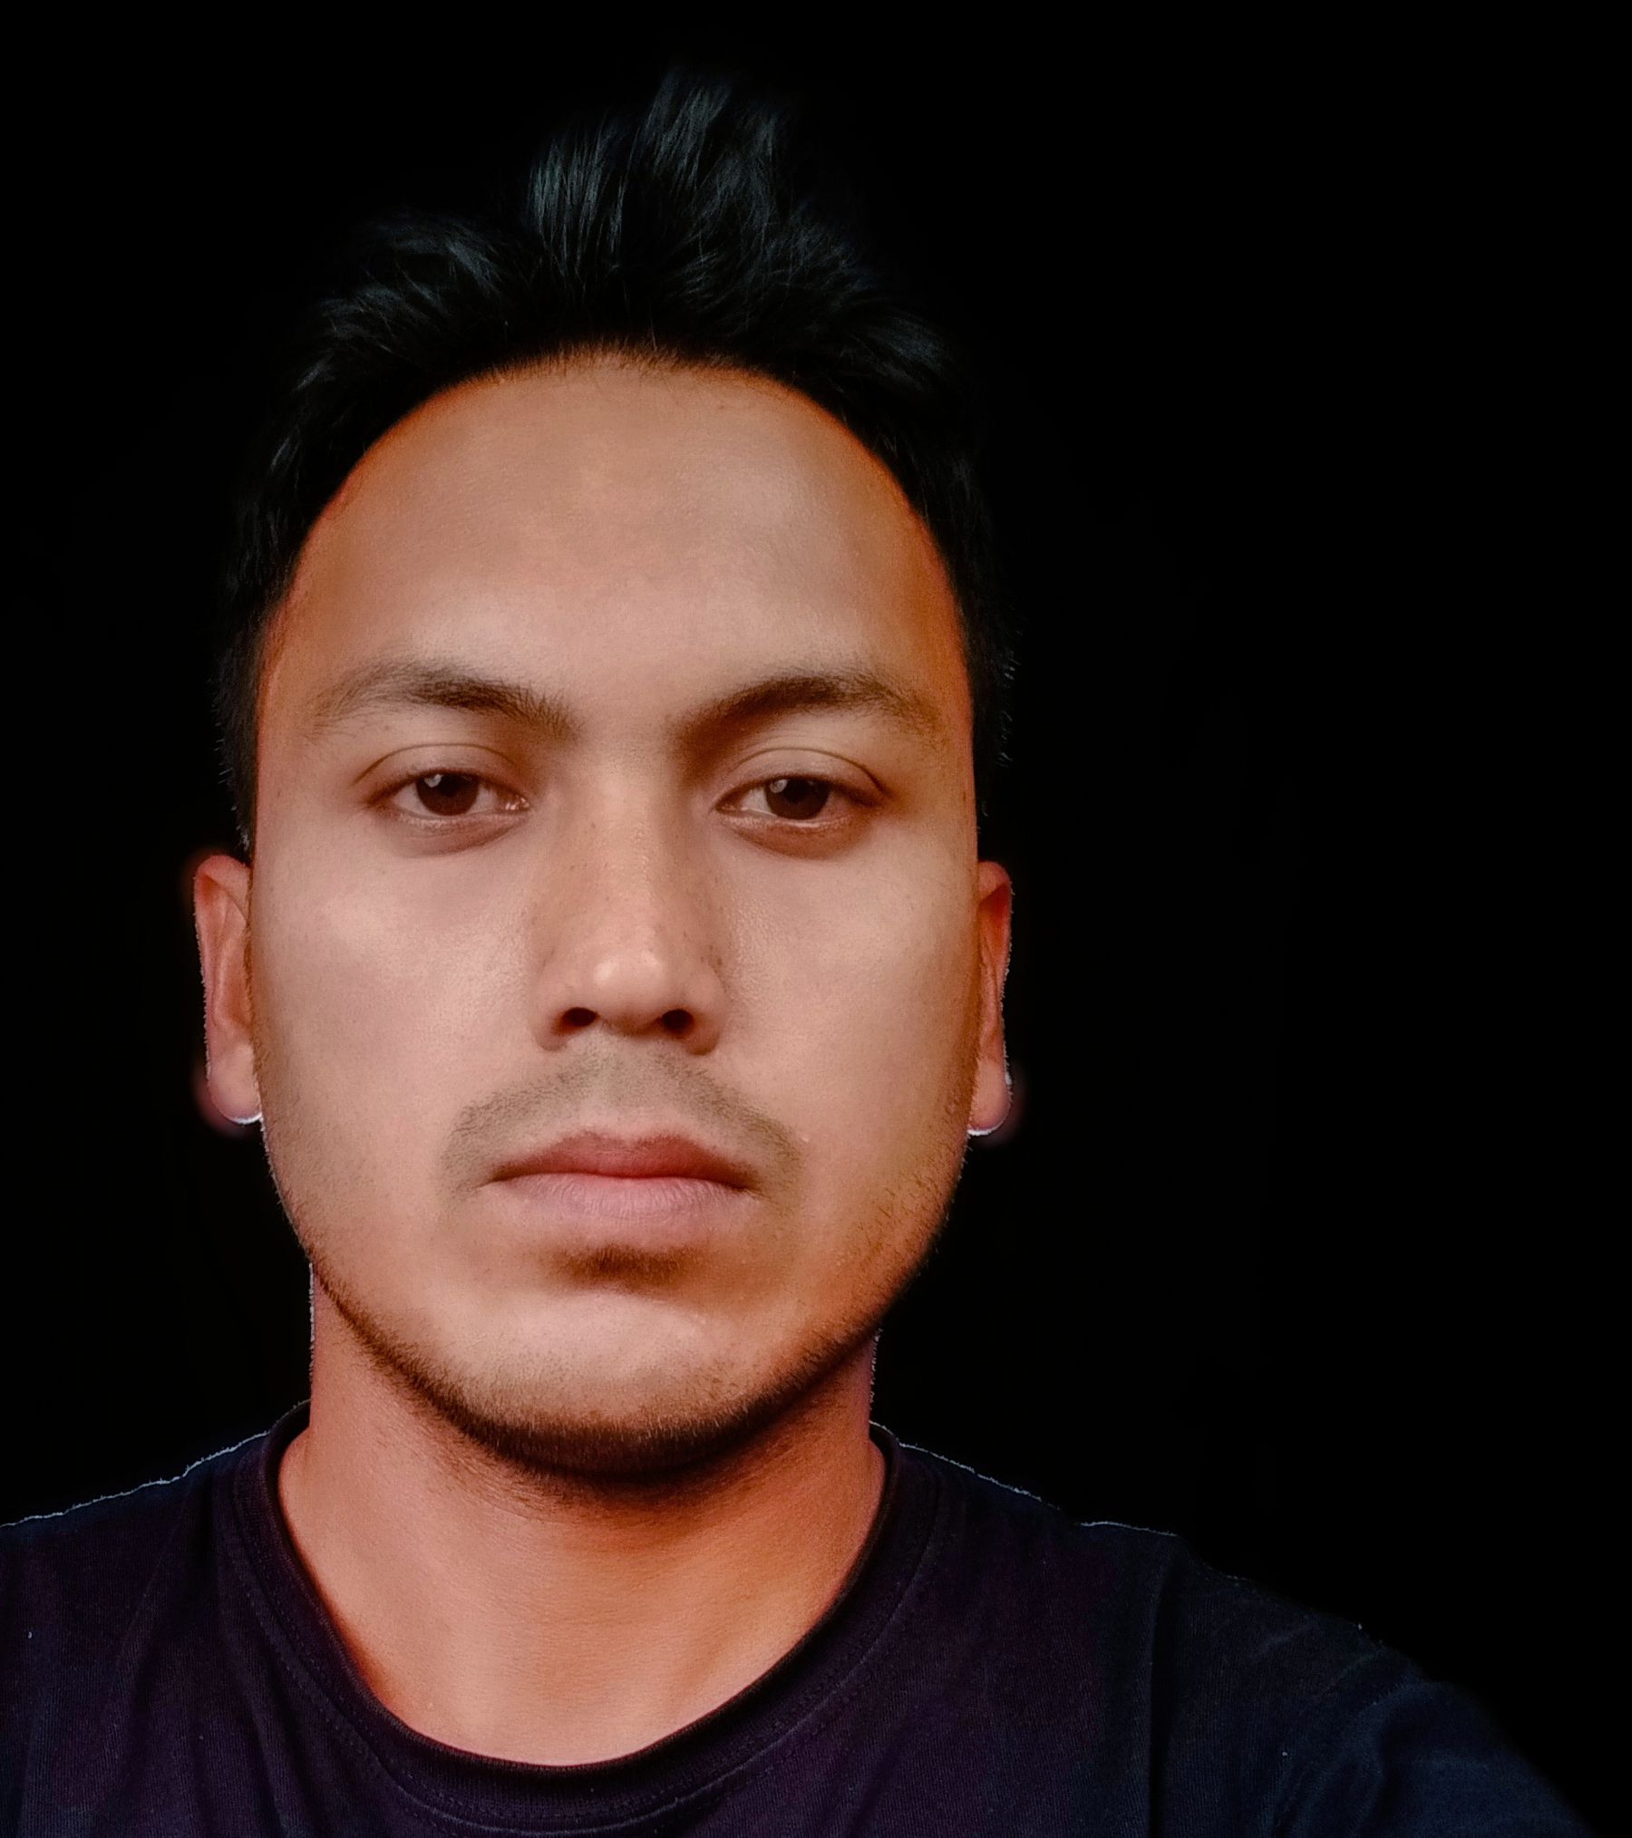

**Senior FULL STACK software engineer** specializing in web development. Experienced with all stages of the development cycle for dynamic web projects. Well-versed in numerous programming languages including JavaScript, PHP, Python, Ruby, RUST and in project management and customer relations.